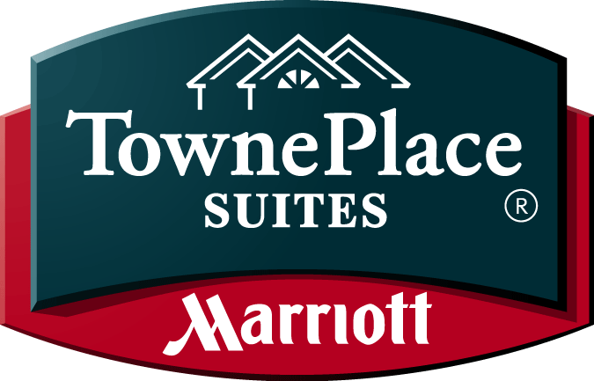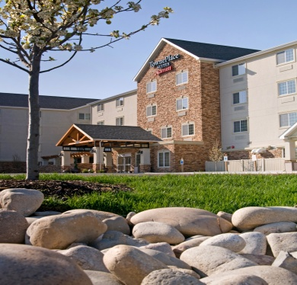

1455 S. Capital Blvd ● Boise Downtown ● ID ● 83706 ● 208-429-8881 ● 208-429-8884 Fax

Welcome

The TownePlace Suites by Marriott is thrilled to be considered as a hotel venue for your upcoming stay. We are eager to impress you with our beautiful accommodations and professional service Marriott guests have come to expect.

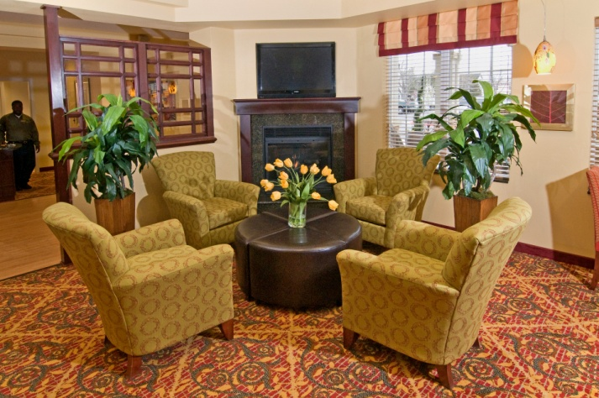

TownePlace Suites Boise Downtown – Designed for Real Living
The TownePlace Suites by Marriott Boise Downtown is a beautiful Platinum Award Winning, all-suite hotel located in the heart of Boise. You will enjoy the locale, nestled next to Ann Morrison Park, just under a mile away from downtown Boise. Relax and feel at home in our Studio King, Double Queen or a Two Bedroom Suite, with a fully equipped kitchen in every room.

GUEST ROOM FEATURES

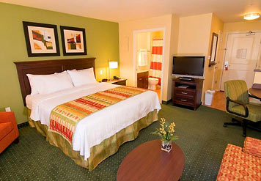
- Fully Equipped Kitchen
- Complimentary high speed Internet access
- Spacious work desk, ergonomic chair
- 32 inch plasma television w/HD channels
- Refrigerator, microwave and stove
- Hairdryer, iron and ironing board
- Dishwasher
- Express check out and free local calls
- Marriott new luxurious supreme bedding experience

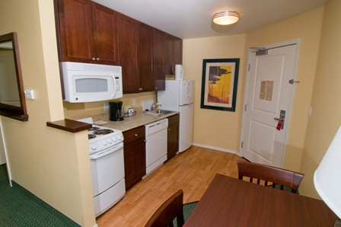
EXTENDED STAY TRAVELER

TownePlace Suites by Marriott is a mid-priced residential-style hotel, designed for longer-stay travelers. It’s the ideal solution
for people who are relocating, need temporary housing, or are attending a training course. TownePlace Suites is a place you
can call home.
When you’re going to be away for a week or more, we recognize
just how unique your needs are. At TownePlace Suites you’ll have just what you need… all for a price that you can afford
and without the hassles of a lease.

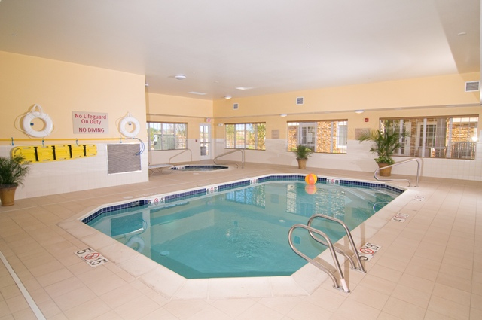
On-site Amenities & Services
- Indoor pool and spa
- 24-hour fitness center
- Complimentary breakfast
- Business center
- 880 square foot meeting/event room
- 24 hour Market area featuring snacks and necessities
- Patio featuring gas grill
- Complimentary wireless and wired technology
in all public areas
- On-site self service guest laundry facilities
and same day valet laundry service (M-F)

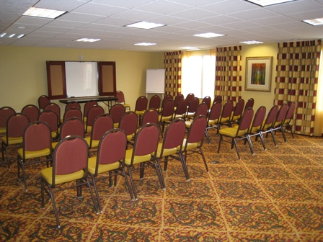
BOOK YOUR NEXT MEETING

Our meeting room is approximately 880 square feet.
Accommodate up to 90 people depending on the set up.
Audio/Video Equipment (Rentals Available)
Breakfast Buffett and Beverage Services
Catering Services by Local Restaurants

- Company Trainings
- Seminars and Speaker Programs
- Product Presentations
- Government or Military Meetings
- Lunch or Group Meetings
- Class Reunions
- Weddings

RESERVATION METHOD

Please make your Reservations by calling the hotel directly at (208)429-8881

Please refer to the Promoting a Healthy Idaho when making reservation to receive the special rate of $79 + tax. Rooms are subject to availability, book early. All reservations must be guaranteed with a valid credit card. Check-in is at 4 pm and check-out is 12 pm.

Go to www.marriott.com/boits for a photo tour of the hotel.

