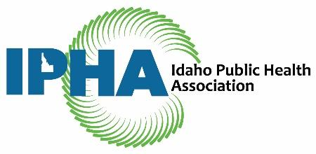
IPHA - 2019 Student Excellence Award Announcement
One $500 IPHA Student Excellence Award is available to IPHA student members enrolled in an undergraduate or graduate degree program in a public health related area of study. The announcement for the 2019 award will take place at the Idaho Public Health Association PHED talks event on April 2, 2019.
The application deadline is March 25, 2019.
Eligibility Criteria: Student must be a current member of IPHA. For information about IPHA and to become a member, please visit IPHA website.
Academic requirement: the course of study must be supportive of a public health related field.
Educational level: undergraduate or graduate is currently attending an Idaho school.
Commitment: In return for being awarded the Student Excellence Award the awardee agrees to complete one of the three activities below:
- Contribute writing two articles in the IPHA newsletter
- Participate in quarterly IPHA board meetings (remotely or in person)
- Present to two classes or other student gatherings on the role of IPHA and its benefits to students
Eligible submissions must include:
- completed application (40 points),
- resume (5 points), and
- list two references (one academic, one character) (5 points).
Evaluation Criteria:
Each application will be reviewed and scored by the IPHA Board of Directors. The weight of each component is listed on this announcement and within the application package.
Applications must be submitted electronically to idpublichlth@yahoo.com
by Monday, March 25th, 2019.

Idaho Public Health Association – 2019 Student Excellence Award Application
Applications are due Monday, March 25, 2019
Applicant Information
Name: Click or tap here to enter text.
Address (present): Click or tap here to enter text.
Address (permanent, if different): Click or tap here to enter text.
Telephone: Click or tap here to enter text.
Email Address: Click or tap here to enter text.
Date of initial IPHA Membership: Click or tap here to enter text.

Education
University: Click or tap here to enter text.
Degree program or major: Click or tap here to enter text.
Specialization in major field of study: Click or tap here to enter text.
Number of credits completed in degree program: Click or tap here to enter text.
Current Grade Point Average (GPA): Click or tap here to enter text.
Anticipated date of graduation: Click or tap here to enter text.

Application Questions:
- Describe your goals and how they contribute to public health in Idaho. (200 words) (12 points)
Click or tap here to enter text.
- How would this award impact your ability to pursue your academic goals? (200 words) (12 points)
Click or tap here to enter text.
- Describe your current experience with IPHA and/or public health? (200 words) (8 points)
Click or tap here to enter text.
- How do you see yourself contributing to IPHA in the future? (200 words) (6 points)
Click or tap here to enter text.
Additional Application Components:
☐Resume Attached (5 points)
☐List of two references (one academic, one character) with contact information and brief description of relationship (5 Points)
Completeness of application (2 points)

