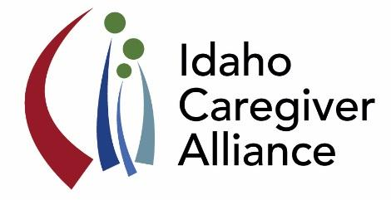
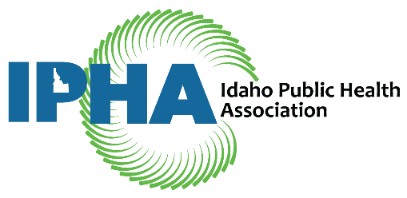

Health Policy Opportunity: Idaho Public Health Association and
Idaho Caregiver Alliance Legislative Policy Analyst

Description:
This legislative policy analyst position is a collaborative project of the Idaho Public Health Association (IPHA) and Idaho Caregiver Alliance (ICA). The primary duty of the intern is to publish a weekly “Legislative Update” newsletter during the 2021 Idaho State Legislative Session. The session convenes on January 11, 2021 and continues through March or April 2021. Other activities include:
- Attending legislative sessions in person or online (preferred due to COVID).
- Identifying and summarizing pieces of legislation related to public health, families and family caregivers.
- Tracking the progress of legislation throughout the legislative session.
- Representing ICA at applicable public health advocacy days during the legislative session.
- Meeting regularly with the ICA and IPHA Policy Mentors.

The Intern will also prepare an end of session report for distribution to IPHA and ICA members. Please see LINK for examples of past Legislative Updates.

Qualifications:
Preference for a graduate student in health science, nursing, public health, public administration, communications, or similar field; will also consider a well-qualified upper-division undergraduate with a strong interest in health policy. The ideal candidate is an exceptional writer, computer savvy, creative, pragmatic, and works well with minimal supervision.

Time Commitment:
10-12 hours per week during the legislative session (approximately 12-13 weeks)
The Policy Intern will need to commit a minimum of 10-12 hours per week during the legislative session, as follows:
- Approximately 4-6 hours attending legislative hearings (in person or online), meeting with stakeholders, and communicating with IPHA and ICA Policy mentors regarding pertinent pieces of legislation.
- Approximately 2-3 hours researching legislation online.
- 4-5 hours preparing the weekly Legislative Update.

Stipend and Support:
$800.00 stipend (awarded at the end of the experience)
The intern will be supervised by Sarah Toevs, member of IPHA Board and ICA Leadership Team. The experience can also serve as an academic internship with approval of the student's faculty advisor.

The Intern will have numerous opportunities to:
- Gain an in-depth understanding of the legislative process in Idaho.
- Opportunity to meet and interact with policymakers in Idaho.
- Have your writing (with your “by line”) read by a broad and highly interested audience.

How to Apply: Please submit a cover letter, resume, and contact information for two (2) references to Sarah Toevs, stoevs@boisestate.edu. Include IPHA/ICA Policy Analyst in the Subject line of message.
Deadline: Monday, December 7, 2020. Please contact Sarah if you have questions.
About IPHA:
Established in 1952, the Idaho Public Health Association (IPHA) is the oldest nonprofit organization representing public, private and consumer health interests in Idaho. The purpose of IPHA is to foster and support improvements in the health and welfare of Idaho citizens and to provide a forum for the expression and dissemination of current health issues, trends and technologies. www.Idahopublichealth.org

